

**Assignment / Tutorial / Project / Report Cover Sheet**

|  |  |  |
| --- | --- | --- |
| Programme | : | Diploma in Information Technology |
| Subject Code | : | CSIS2063 |
| Subject Name | : | Project Management |
| Lecturer Name | : | Chan Ler Kuan |
| Academic Session | : | 2023B |

**Detail:**

|  |  |
| --- | --- |
| Assignment / Tutorial / Project / Report Title: | Group Project |
| Names: | Pang Dixon  Ho Ren Hao  Pua Tian Jin  Chong Jian Jin |
| Student ID: | D210231C  D210255C  D210179C  D210257C |
| Phone No: | 60127919172  60127728877  60199496632  60186625854 |
| Email: | [D210231C@sc.edu.my](mailto:D210231C@sc.edu.my)  [D210255C@sc.edu.my](mailto:D210255C@sc.edu.my)  [D210179C@sc.edu.my](mailto:D210179C@sc.edu.my)  D210257C@sc.edu.my |
| Due Date: | 14/8/2023 4pm |

**Assessment:**

|  |  |
| --- | --- |
| **MARK:** | Comments: |

# Table of Content

1.0 Introduction 3

2.0 Project Scope 3

3.0 Project Charter 4

4.0 Mind map 6

5.0 Organization chart · 7

6.0 Work Breakdown Structure (WBS) 10

7.0 Gantt chart 11

8.0 Cost estimation 12

9.0 Network Diagram 13

10.0 Prototyping 15

11.0 Conclusion 17

# Introduction

The project is called lens supplier inventory management system, in nowadays there is a system that already exist but lack of efficiency and lack of convenience. This project will have a customer service, coordinating with partners, managing distribution, and payment management for merchants that who want to order the lenses. The system will also include a user-friendly interface for browsing and ordering lenses, integration with a payment gateway, inventory management tools, a supplier management module, and reporting and analytics equipment.

# 2.0 Project Scope

This system will be used to help merchants who want to order lens to order lens more conveniently. The aim is to boosts customer service, bring coordination among partners, manage distribution, supplier management, inventory management and payment management. To achieve these goals, this system will include a simple user interface that enables merchants to simply navigate and select lenses, in addition track the status of their orders, Integration with a payment gateway to allow merchants to make secure online payments, Tools for managing inventory, such as alerts when stock levels are low and the ability to place reorder requests, A supplier management module to help merchants communicate with and manage their relationships with lens suppliers, A supplier management module to help merchants communicate with and manage their relationships with lens suppliers.

# 3.0 Project Charter

1. Project Title: Lens Supplier management system

2. Authorization date: 28 June 2023

3. Start date: 28 June 2023

4. Finish date: 6 August 2023

5. Milestone:

* Milestone 1 Requirements gathering, and analysis completed before 30 June 2023(Friday)

-Gather the stakeholders and team members have a meeting and communicate about the specific requirement of the project.

* Milestone 2 System design completed before 9 July 2023(Sunday)

-Design the system architecture, database, and user interface

-Develop the system prototype

* Milestone 3 System Development completed before August.

-Integrate the system with the payment gateway and inventory management tools.

* Milestone 4 Testing before 6 August 2023 (Sunday)

-unit testing and integration testing

6. Budget:

* RM80K will be required for this project, the majority of fund will be internal labour but part of fund will be buying the servers for hosting the project.

7. Project Manager: Pang Dixon, (+60127919172), [pangdixon34@gmail.com](mailto:pangdixon34@gmail.com)

8. Project Objective:

* To complete a new inventory management system that will improve efficiency and convenience for merchants, improve customer service, and streamline the overall lens ordering process.

9. Project success criteria:

* The system must be easy to use for merchants of all levels of technical expertise.
* The system must provide a secure payment gateway for merchants to make online payments.
* The system must track inventory levels and reorder supplies automatically.
* The system must communicate with and manage relationships with lens suppliers.

10. Approach:

* Within one month develop a clear work breakdown structure, scope and Gantt chart detailing the work required to complete project.
* Involve stakeholders early and often. Get feedback from merchants, lens suppliers, and internal staff on the requirements, design, and testing of the system.
* Test the system thoroughly. Don't just test the system once it is developed. Test it at every stage of the development process and get feedback from users.
* Purchase all required hardware within two months.

11. Roles and responsibilities:

|  |  |  |  |
| --- | --- | --- | --- |
| Name | Role | Position | Contact Information |
| Pang Dixon | Project Manager | Manager | [Pangdixon34@gmail.com](mailto:Pangdixon34@gmail.com) |
| Ho Ren Hao | Team Member | Software Developer | [Horenhao@gmail.com](mailto:Horenhao@gmail.com) |
| Pua Tian Jin | Team Member | Software Tester | [Puatianjin@gmail.com](mailto:Puatianjin@gmail.com) |
| Chong Jian Jin | Team Member | UI/UX Designer | Chongjianjin@gmail.com |

**Table 1 roles and responsibilities in project charter**

# 4.0 Mind map

**Figure 1 mind map of lens management system**

# 5.0 Organization chart

**Figure 2 Organization chart of project**

|  |  |  |
| --- | --- | --- |
| Role | Name | Responsibilities |
| Project Manager | Pang Dixon | As a project manager, the responsibilities is to create a project planning, budget management, scope management, time management and act as a main point of contact for stakeholders, informed them about the project progress, get the approval from stakeholders if any changes being implement |
| Software Developer | Ho Ren Hao | As a software developer, the main responsibilities involve creating and maintaining software applications by writing code, testing, and collaborating with other teams to meet project requirements and ensure high-quality software. |
| UI/UX Designer | Chong Jian Jin | My main responsibilities for User Interface (UI) and User Experience (UX) designer revolve around creating digital products and experiences that are user-friendly, visually appealing, and functionally effective. Their goal is to ensure that users can interact with a digital product or application in a seamless and satisfying way. |
| Software Tester | Pua Tian Jin | A software tester's responsibilities encompass a variety of tasks aimed at ensuring the quality, functionality, and reliability of software applications. Testers play a critical role in the software development lifecycle, helping to identify and rectify defects and issues before software is released to users. |

**Table 2 Details of roles and responsibilities**

# 6.0 Work Breakdown Structure (WBS)

|  |  |  |  |  |
| --- | --- | --- | --- | --- |
| WBS No | Section / Phase | WBS Task | Assigned to | Duration (week) |
| 1 | Project Initiation and Planning Phase | 1.1 Define project objectives and requirements  1.2 Gather functional and non-functional requirements  1.3 Develop project plan and project schedule  1.5 Establish communication plan  1.6 Establish Quality Assurance Processes | Pang Dixon | 1 week |
| 2 | Design | 2.1 Website design  2.2 Create wireframes and Mock-ups  2.3 Design user interface (UI)  2.4 Develop user experience (UX) design | Chong Jian Jin | 2 week |
| 3 | Development | 3.1 Front-End Development  3.2 Develop home page  3.3 Implement product listing pages  3.4 Design product detail pages  3.5 Create shopping cart functionality  3.6 Back-End Development  3.7 Set up database architecture  3.8 Build product management system | Pua Tian Jin | 4 weeks |
| 4 | Testing and Quality Assurance | 4.1 Conduct unit testing  4.2 Execute user acceptance testing  4.3 Identify and resolve bugs and issues  4.4 Test performance and scalability | Ho Ren Hao | 1 week |
| 5 | Content Creation and Upload | 5.1 Write product descriptions  5.2 Obtain high quality product images  5.3 Upload product information and ensure consistent content formatting | Chong Jian Jin | 1 week |
| 6 | Startup and post-startup activities | 6.1 Monitoring system stability and performance  6.2 Troubleshoot any post-boot issues  6.3 Collect user feedback and implement improvements | Pang Dixon | 1 week |
| 7 | Maintenance | 7.1 Regularly update content and products  7.2 Perform software updates and security patches  7.3 Monitor and optimize system performance | Pua tian Jin | 1 week |

**Table 3 Work Breakdown Structure (WBS)**

# 7.0 Gantt chart

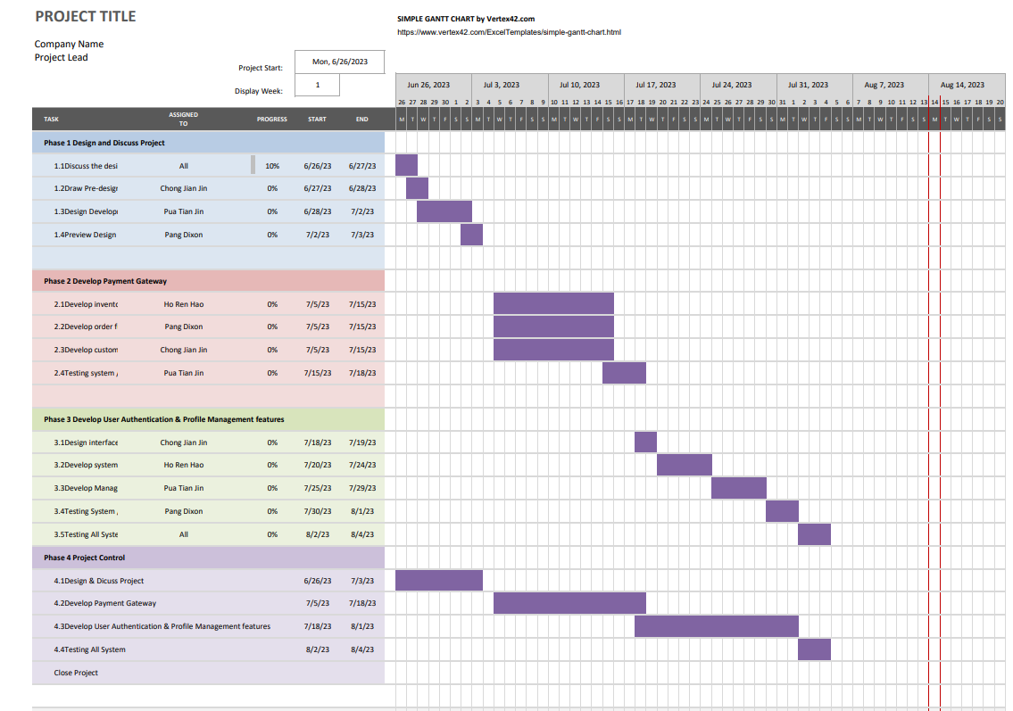

**Figure 3 Gantt chart**

# 8.0 Cost Estimation

|  |  |  |  |  |  |
| --- | --- | --- | --- | --- | --- |
|  | unit/hrs | cost/unit/hr | Subtotals | WBS Level 2 Totals | % of Total |
| WBS item |  |  |  |  |  |
| 1.Project Management |  |  |  | 15390 | 24% |
| Project Manager | 164 | 40 | 7380 |  |  |
| Project team members | 224 | 30 | 6720 |  |  |
| Contractors |  |  | 1290 |  |  |
| 2.Hardware |  |  |  | 15000 | 24% |
| Handheld device | 4 | 2000 | 8000 |  |  |
| server | 1 | 15000 | 15000 |  |  |
| 3 software |  |  |  | 14000 | 22% |
| Licensed software | 4000 |  | 4000 |  |  |
| Software development | 10000 |  | 10000 |  |  |
| 4. Testing |  |  | 2900 | 2900 | 4% |
| 5.Training and support |  |  |  | 8700 | 14% |
| Trainee cost | 120 | 30 | 3600 |  |  |
| Travel cost | 15 | 100 | 1500 |  |  |
| Project team members | 120 | 30 | 3600 |  |  |
| 6 Reserves |  |  | 11198 | 11198 | 18% |
| Total project cost estimate |  |  |  |  | 61788 |

**Table 5 Cost Estimation**

# 9.0 Network Diagram

|  |  |  |
| --- | --- | --- |
| ACTIVITY | PREDECESSOR | DURATION (WEEK) |
| START | - | 0 |
| A .PLAN , RESEARCH | - | 2 |
| B .DEFINE PROJECT SCOPE | - | 2 |
| C .METHODOLOGY | A,B | 2 |
| D. DEVELOP PROJECT | C | 3 |
| E .DEVELOP MANAGEMENT | C | 3 |
| F .DEVELOP PAYMENT GATEWAY | D,E | 3 |
| G. DESIGN INTERFACE | F | 1 |
| H. USER FEEDBACK | F | 1 |
| I .TESTING ALL SYSTEM | G,H | 1 |
| END | I | - |

**Table 6 Network Diagram**

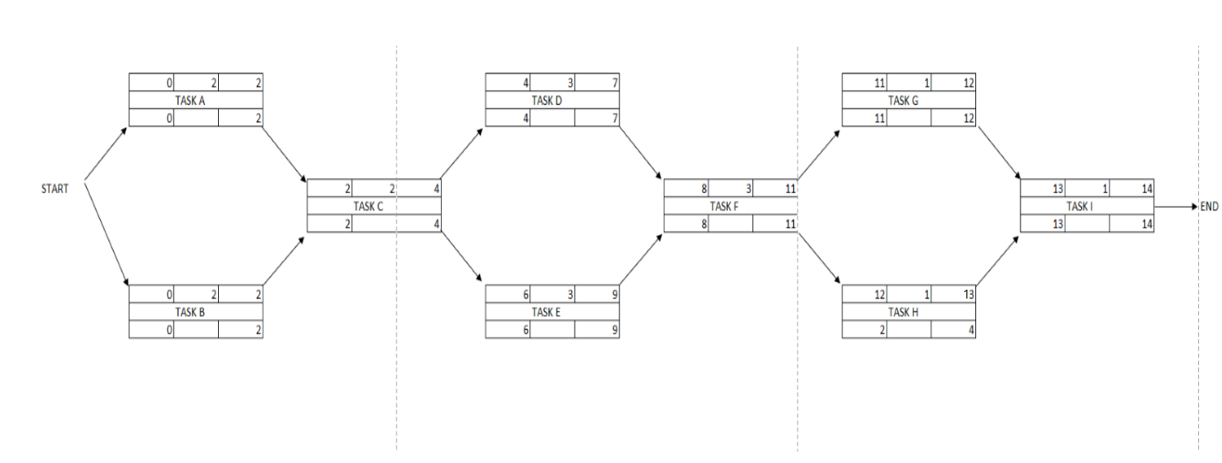  
**Figure 4 Network Diagram**

# 10.0 Prototyping

**Prototype**

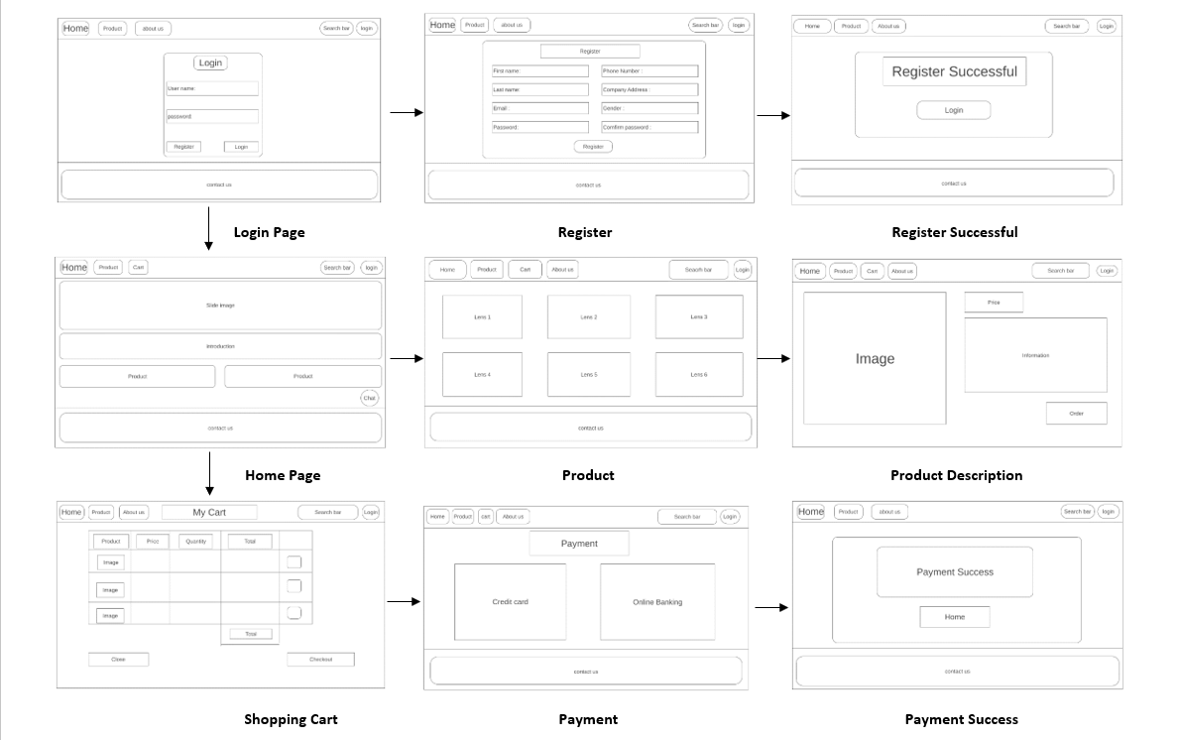

**Figure 5 prototype of user page**

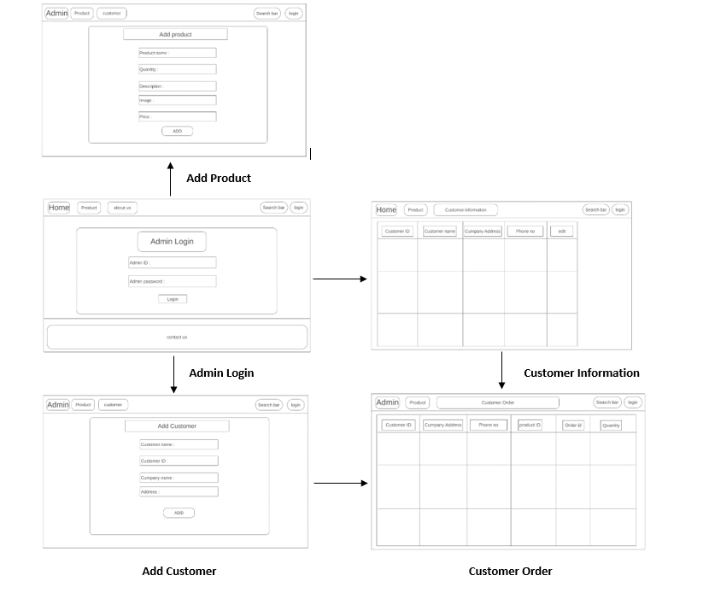

**Figure 5.1 Prototype of admin page**

# 11.0 Conclusion

The lens supplier inventory management system project is a complex and challenging undertaking, but it has the potential to significantly improve the efficiency and convenience of the lens ordering process for merchants. By implementing a new system with features such as a user-friendly interface, integration with a payment gateway, inventory management tools, a supplier management module, and reporting and analytics equipment, the project can help to streamline the lens ordering process and improve customer service.

The project will also require careful planning and execution in order to be successful. It is important to involve stakeholders early and often, use a proven development methodology, test the system thoroughly, and deploy the system carefully. By following these steps, the project team can increase the chances of success and deliver a system that meets the needs of the lens supplier and its customers.

# References

Diagrams.net. (n.d.). Retrieved from https://app.diagrams.net/

ProjectManager. (n.d.). Cost Estimation for Projects: How to Estimate Accurately.

https://www.projectmanager.com/blog/cost-estimation-for-projects

Schwalbe, K. (n.d.). Information Technology Project Management Ninth Edition. [Book].

Forbes Advisor. (n.d.). What Is Work Breakdown Structure (WBS) in Project Management?

https://www.forbes.com/advisor/business/what-is-work-breakdown-structure/

Purdue University. (n.d.). Project Manager Job Description & Career Outlook.

https://www.purdue.edu/projectmanagementcertification/news/project-manager-job-description-career-outlook/

Test Institute. (n.d.). Software Testing Roles And Responsibilities.

https://www.test-institute.org/Software_Testing_Roles_And_Responsibilities.php

KnowledgeHut. (n.d.). Software Developer Roles and Responsibilities.

https://www.knowledgehut.com/blog/web-development/software-developer-roles-and-responsibilities

Simplilearn. (n.d.). UI/UX Designer Job Description: Role, Responsibilities, and Skills.

https://www.simplilearn.com/tutorials/ui-ux-career-resources/ui-ux-designer-job-description

Book 3 cost estimating in an agile development ... - alvinalexander.com. (n.d.). https://alvinalexander.com/downloads/Book3-EstimatingInAnAgileEnvironment.pdf

Vitalsource Bookshelf Online. (n.d.). https://online.vitalsource.com/reader/books/9781337515856/pageid/333

# Rubric for Project

|  |  |  |  |  |
| --- | --- | --- | --- | --- |
| **Criteria (Part I**  **- Contents)** | **Requires Revision to Meet Requirements**  **(0 - 3 marks)** | **Meets Minimum Requirements**  **(4 - 6 marks)** | **Exceeds Requirements**  **(7 – 9 marks)** | **Marks** |
| Group Information (Company name, Stakeholder register, Sphere Model (10 questions for each category – Business, Organization, Technology), Project Manager) | * Unclear group information * Most of the information are not in detail | * Clear group information * Some of the information are in detail | * Very clear group information * Most of the information are in detail |  |
| Introduction  of project | * Unclear definition /   description of project | * Clear definition /   description of project | * Very clear definition /   description of project |  |
| Project Scope | * Unclear definition / description of project scope * Most of the project scope are not discussed   and not related to project | * Clear definition / description of project scope * Some of the project scope are discussed and   related to project | * Very clear definition / description of project scope * All the project scope are discussed and   related to project |  |
| Project Charter | * Most of the project charters are not discussed.   • | * Some project charters are discussed. | * All project charters are clearly defined. |  |
| Mind Map | * Unclear mind map * Most of the mind map data are not in detail, not related to project and   incorrect | * Clear mind map * Some of the mind map data are in detail and correct, related to project | * Very clear mind map * Most of the mind map data are in detail and correct, related to   project |  |
| Chart | * Unclear project chart * Most of the project chart data are incorrect and not related to project | * Clear project chart * Some of the project chart data are correct and related to project | * Very clear project chart * Most of the project chart are correct and   related to project |  |
| WBS | * Unclear WBS | * Clear WBS | * Very clear WBS |  |
|  | * Most of the WBS data are incorrect and not   related to project | * Some of the WBS data are correct and related to   project | * Most of the WBS are correct and related to   project |  |
| Gantt Chart | * Unclear Gantt Chart * Most of the Gantt Chart data are incorrect and   not related to project | * Clear Gantt Chart * Some of the Gantt Chart data are correct and   related to project | * Very clear Gantt Chart * Most of the Gantt Chart are correct and   related to project |  |
| Cost Estimation | * Unclear Cost Estimation and justification * Most of the Cost Estimation data are incorrect and not related   to project | * Clear Cost Estimation and justification * Some of the Cost Estimation data are correct and related to   project | * Very clear Cost Estimation and justification * Most of the Cost Estimation are correct   and related to project |  |
| Network Diagram | * Unclear Network Diagram * Most of the Network Diagram data are incorrect and not related   to project | * Clear Network Diagram * Some of the Network Diagram data are correct and related to project | * Very clear Network Diagram * Most of the Network Diagram are correct and related to project |  |
| Criteria (Part  II – Report Format) | Requires Revision to Meet Requirements  (0 - 3 marks) | Meets Minimum Requirements  (4 - 7 marks) | Exceeds Requirements  (8 – 10 marks) | Marks |
| Report and Documentation | The report is not in a suitable format. Spelling and grammar are both weak and the use of diagrams is poor. The report is of unsatisfactory length with significant padding throughout. | The report may deviate from the preferred format but is presented in a reasonably alternative manner. The spelling, grammar and use of diagrams are satisfactory. The report is overall well written with little padding and is of acceptable length. | The report is in the preferred format. The spelling and grammar are excellent, and diagrams aid the understanding of the text significantly in terms of their relevance and location; the report is extremely well written, focused and without padding. The report is of the correct length. |  |
|  |  |  | **TOTAL (100 MARKS)** |  |

